TERRAFORM-03
TASK 1 — Terraform Variables
1. First understand what a variable is
Suppose your Terraform code has:
resource "local_file" "pet" {
filename = "/root/pets.txt"
content = "We love pets"
}
Here /root/pets.txt is hard-coded.
If tomorrow you want:
/tmp/pets.txt
you have to modify main.tf.
Instead, we create a variable:
variable "filename" {
default = "/root/pets.txt"
}
Then:
resource "local_file" "pet" {
filename = var.filename
content = "We love pets"
}
Now the value can be changed without modifying the resource.
Basic syntax
variable "filename" {
default = "/root/pets.txt"
type = string
description = "Path of the file to create"
}
And use it as:
var.filename

2. Create a Terraform practice directory
On your Terraform server:
mkdir terraform-variables
cd terraform-variables
Check:
pwd
You should see something like:
/home/ec2-user/terraform-variables
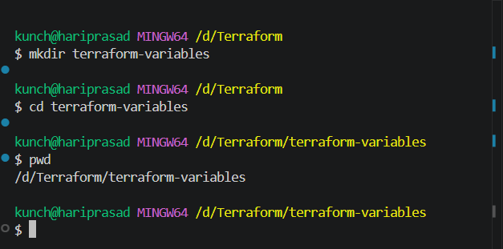

3. Create main.tf
Run:
vi main.tf
Put this:
terraform {
required_providers {
local = {
source = "hashicorp/local"
version = "~> 2.5"
}
}
}

provider "local" {}

resource "local_file" "pet" {
filename = var.filename
content = "We love pets"
}
Save:
ESC
:wq
ENTER

4. Create variables.tf
vi variables.tf
Add:
variable "filename" {
default = "/root/pets.txt"
type = string
description = "Path of the file to create"
}
Save.
Now we have:
terraform-variables/
├── main.tf
└── variables.tf
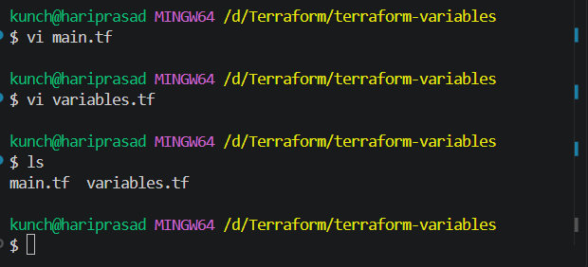

5. Understand the variable block
This:
variable "filename" {
default = "/root/pets.txt"
type = string
description = "Path of the file to create"
}
means:
variable "filename"
Variable name is:
filename
default
default = "/root/pets.txt"
If nobody provides a value, Terraform uses this value.
type
type = string
It tells Terraform what kind of value this variable accepts.
description
description = "Path of the file to create"
This explains what the variable is used for.

6. Initialize Terraform
Run:
terraform init
You should see Terraform downloading the local provider.
Then:
terraform validate
Expected:
Success! The configuration is valid.
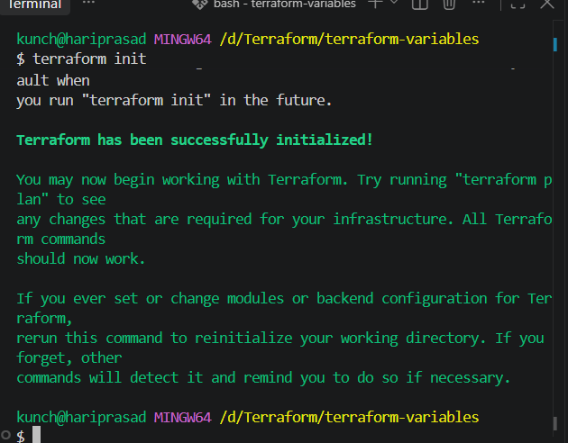

7. Run Terraform plan
terraform plan
Terraform should show that it will create:
local_file.pet
You should see something similar to:
Plan: 1 to add, 0 to change, 0 to destroy.
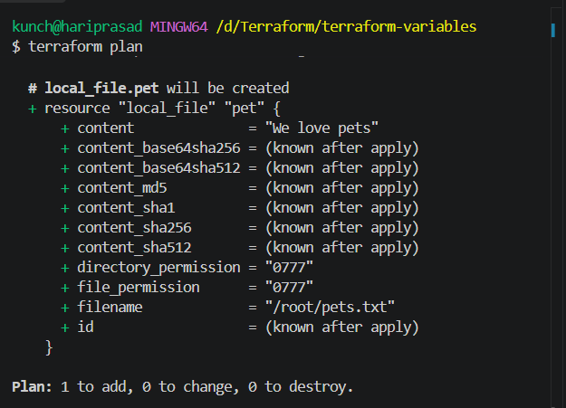

8. Apply
terraform apply
Terraform asks:
Do you want to perform these actions?
Enter:
yes
Now check:
ls -l /root/pets.txt
And:
cat /root/pets.txt
Expected:
We love pets
🎯 First variable completed.
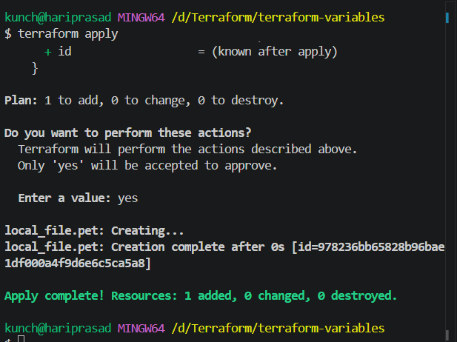

9. Now understand string
A string is text.
Example:
variable "pet_name" {
type = string
default = "cat"
}
Use:
content = "My pet is ${var.pet_name}"
Result:
My pet is cat
Other examples:
"hello"
"terraform"
"cat"
"/root/pets.txt"

10. Number variable
Now let's practice number.
Modify variables.tf:
variable "pet_count" {
type = number
default = 3
}
So:
variable "filename" {
default = "/root/pets.txt"
type = string
description = "Path of the file to create"
}

variable "pet_count" {
type = number
default = 3
}
In main.tf, change content:
resource "local_file" "pet" {
filename = var.filename
content = "We have ${var.pet_count} pets"
}
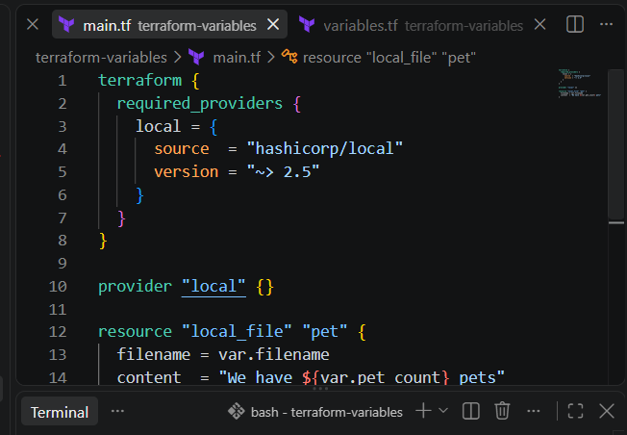
Run:
terraform plan
Then:
terraform apply
Enter:
yes
Check:
cat /root/pets.txt
Expected:
We have 3 pets
Number examples
1
10
100
3.14
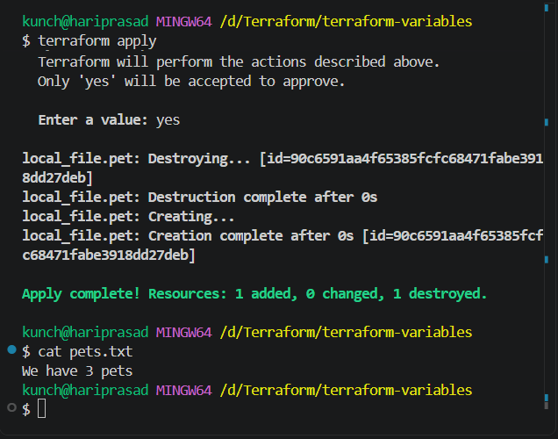

TASK 2 — Terraform + Jenkins Integration
🎯 Goal
By the end, Jenkins should be able to execute Terraform commands.
Our flow:
Developer
↓
GitHub
↓
Jenkins
↓
Terraform
↓
AWS / Infrastructure
For today's basic integration:
Jenkins
↓
terraform version
↓
terraform init
↓
terraform plan
Later we can add terraform apply.

Step 1 — Check Terraform on Jenkins server
SSH into your Jenkins EC2/server.
Run:
terraform version
You should get something similar to:
Terraform v1.x.x
Also check:
which terraform
Example:
/usr/local/bin/terraform
Why are we checking this?
Jenkins must be able to find the Terraform executable.
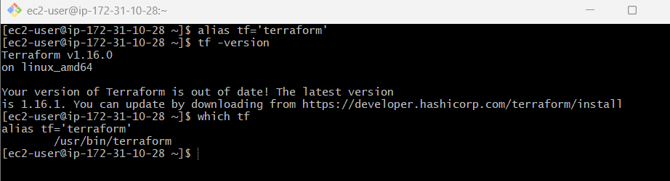

Step 2 — Check Jenkins
Open Jenkins in your browser.
Go to:
Manage Jenkins
Then:
Tools
Depending on your Jenkins version, it may appear as:
Manage Jenkins → Tools

Step 3 — Configure Terraform in Jenkins
Inside Tools, find:
Terraform installations
Click:
Add Terraform
Give it a name:
terraform
This name is important.
For example:
Name: terraform
Then configure the Terraform installation.
If Jenkins provides an automatic installation option, you can select the required Terraform version.
Otherwise, if Terraform is already installed on the Jenkins server, configure it to use the existing installation/path according to the available Jenkins tool configuration.
Click:
Save
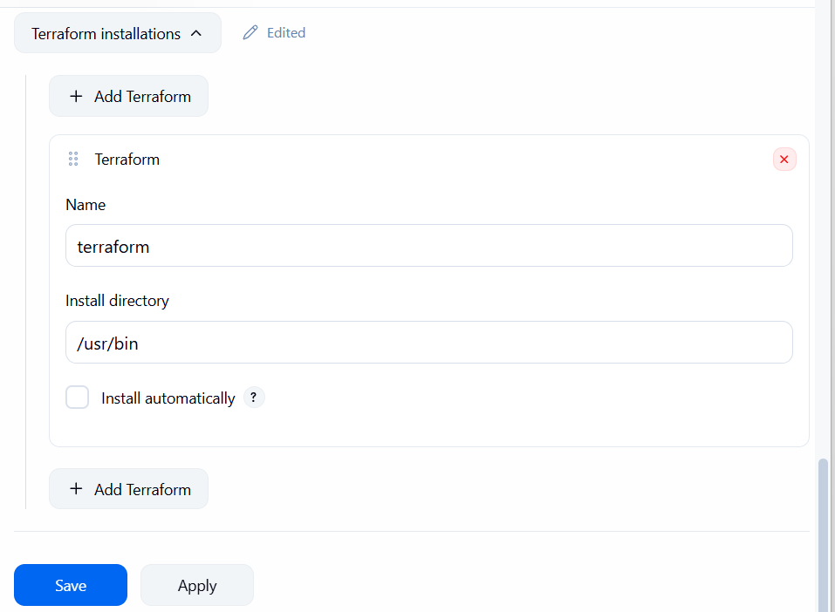

Step 4 — Why do we configure Terraform as a Jenkins Tool?
Suppose your pipeline contains:
terraform version
Jenkins needs to know:
"Where is the Terraform executable?"
The Jenkins Terraform tool configuration tells Jenkins which Terraform installation to use.
Conceptually:
Jenkins
|
|--- Terraform Tool
|
└── terraform executable

Step 5 — Create a Terraform GitHub repository
For this practice, we'll use a small Terraform project.
Your repository can contain:
terraform-jenkins-demo/
│
├── main.tf
├── variables.tf
└── outputs.tf
For example, main.tf:
terraform {
required_providers {
local = {
source = "hashicorp/local"
version = "~> 2.5"
}
}
}

provider "local" {}

resource "local_file" "pet" {
filename = var.filename
content = "We love pets"
}
variables.tf:
variable "filename" {
type = string
default = "pets.txt"
description = "Name of the file"
}
outputs.tf:
output "filename" {
value = local_file.pet.filename
}
Push these files to GitHub.

Step 6 — Create Jenkins Pipeline job
In Jenkins dashboard:
New Item
Enter:
Terraform-Jenkins-Demo1
Select:
Pipeline
Click:
OK

Step 7 — Configure the Pipeline
Go to:
Pipeline
Choose:
Pipeline script
Use:
pipeline {
agent any

tools {
terraform 'terraform'
}

stages {

stage('Checkout') {
steps {
git branch: 'main',
url: ‘https://github.com/venugh8899/terraform-jenkins-demo.git'
}
}

stage('Terraform Version') {
steps {
sh 'terraform version'
}
}

stage('Terraform Init') {
steps {
sh 'terraform init'
}
}

stage('Terraform Plan') {
steps {
sh 'terraform plan'
}
}
}
}
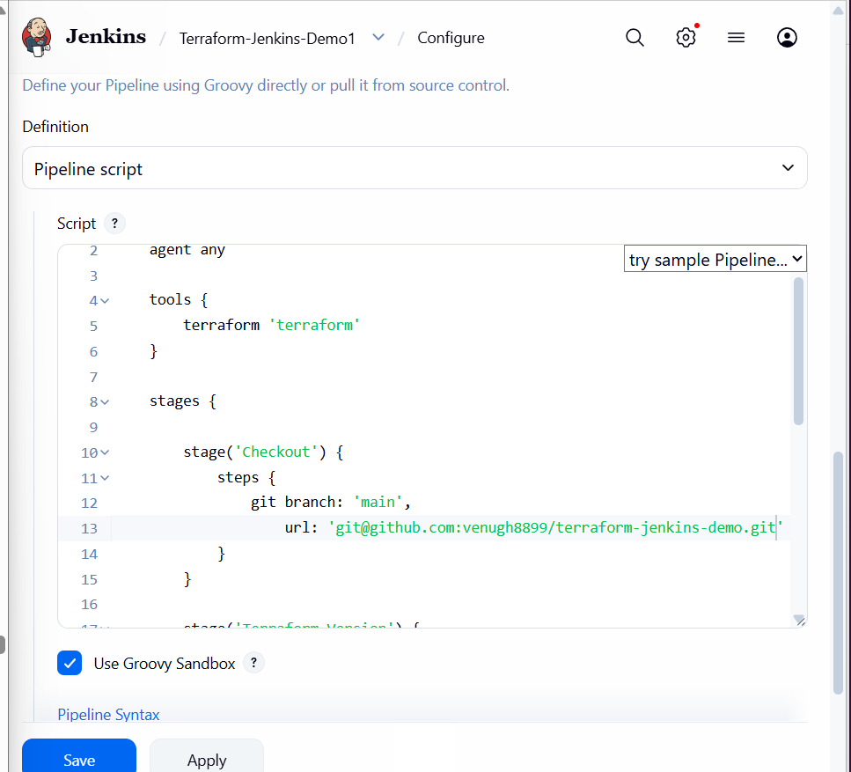
Important line ⭐
tools {
terraform 'terraform'
}
Here:
terraform
↑
Jenkins tool type
and:
'terraform'
↑
Name we configured in Jenkins Tools
So these two names must match.

Step 8 — Save and Build
Click:
Save
Then:
Build Now
Jenkins will execute:
Stage 1
Checkout
↓
GitHub code downloaded

Stage 2
Terraform Version
↓
terraform version

Stage 3
Terraform Init
↓
terraform init

Stage 4
Terraform Plan
↓
terraform plan

Step 9 — Check Console Output
Click the build number.
For example:
#1
Then:
Console Output
Look for:
terraform version
Then:
Initializing the backend...
Initializing provider plugins...
Then:
Terraform has been successfully initialized!
Then:
Terraform will perform the following actions:
And finally:
Plan: 1 to add, 0 to change, 0 to destroy.
🎯 If you see this, Terraform + Jenkins integration is working.

Step 10 — Add Terraform Apply
Once plan works, we can add:
stage('Terraform Apply') {
steps {
sh 'terraform apply -auto-approve'
}
}
Then your pipeline becomes:
Checkout
↓
Terraform Version
↓
Terraform Init
↓
Terraform Plan
↓
Terraform Apply
For a learning lab, -auto-approve is convenient.
In real production pipelines, we normally don't blindly auto-apply infrastructure changes without an approval/control process.

Step 11 — Understand the complete Jenkinsfile
A simple complete version:
pipeline {
agent any

tools {
terraform 'terraform'
}

stages {

stage('Checkout') {
steps {
git branch: 'main',
url: 'YOUR_GITHUB_REPOSITORY_URL'
}
}

stage('Terraform Version') {
steps {
sh 'terraform version'
}
}

stage('Terraform Init') {
steps {
sh 'terraform init'
}
}

stage('Terraform Plan') {
steps {
sh 'terraform plan'
}
}

stage('Terraform Apply') {
steps {
sh 'terraform apply -auto-approve'
}
}
}
}
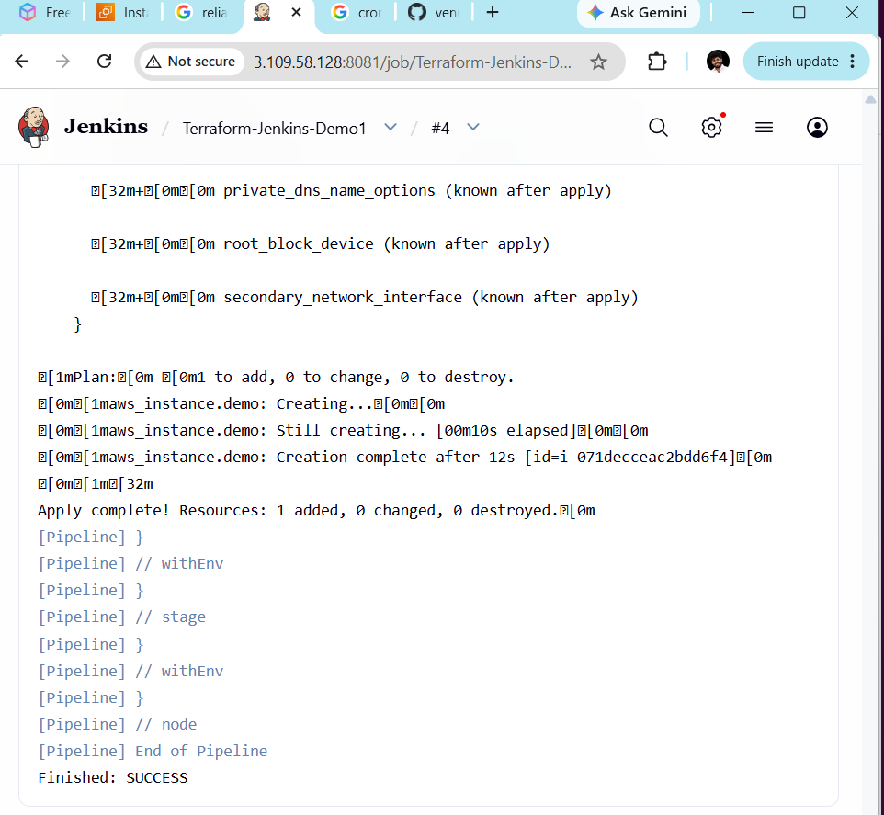

🧠 Understand what is happening
When Jenkins executes:
sh 'terraform init'
it's basically running this Linux command on the Jenkins agent:
terraform init
Similarly:
sh 'terraform plan'
means:
terraform plan
And:
sh 'terraform apply -auto-approve'
means:
terraform apply -auto-approve
So Jenkins is not replacing Terraform.
Jenkins is orchestrating Terraform.
Jenkins = CI/CD automation tool

Terraform = Infrastructure as Code tool
Very important interview point:
Jenkins doesn't create infrastructure by itself. Terraform creates/manages the infrastructure. Jenkins automates the Terraform workflow.

⭐ One important issue you'll encounter
If your Terraform code creates AWS resources, Jenkins needs AWS permissions.
For example:
Jenkins
↓
Terraform
↓
AWS API
↓
EC2 / VPC / S3 / IAM...
Terraform needs AWS credentials/permissions to call AWS APIs.
For your AWS setup, the recommended approach is usually to give the Jenkins EC2 instance an IAM role with the required permissions, rather than putting long-lived AWS access keys directly into the Jenkinsfile.
We'll handle that when we make the Terraform pipeline actually create AWS infrastructure.

TASK 3 — Jenkins Maven Project
Step 1: First verify Maven on Jenkins
SSH into your Jenkins server and run:
mvn -version
You should see something like:
Apache Maven 3.x.x
Java version: 17
Also check Java:
java -version
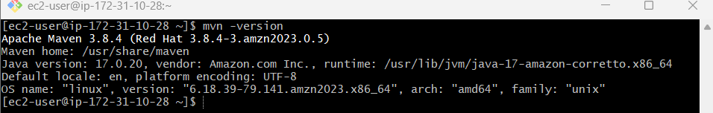
Why?
Maven requires Java.
Java
↓
Maven
↓
Java Application
If mvn -version works, continue.

Step 2: Verify the GitHub repository
The repository we're going to use is:
https://github.com/betawins/java-Working-app.git
It should contain a Maven project.
The important file is:
pom.xml
Think of pom.xml as the main configuration file for a Maven project.
It contains things like:
Project information
Dependencies
Plugins
Build configuration

Step 3: Go to Jenkins
Open Jenkins.
Click:
New Item
Enter:
Java-Working-App
Now select:
Maven project
Then click:
OK

Step 4: Configure Source Code Management
Inside the job configuration, find:
Source Code Management
Select:
Git
Repository URL:
https://github.com/betawins/java-Working-app.git
For branch:
*/main
If the repository's default branch is different, use that branch.
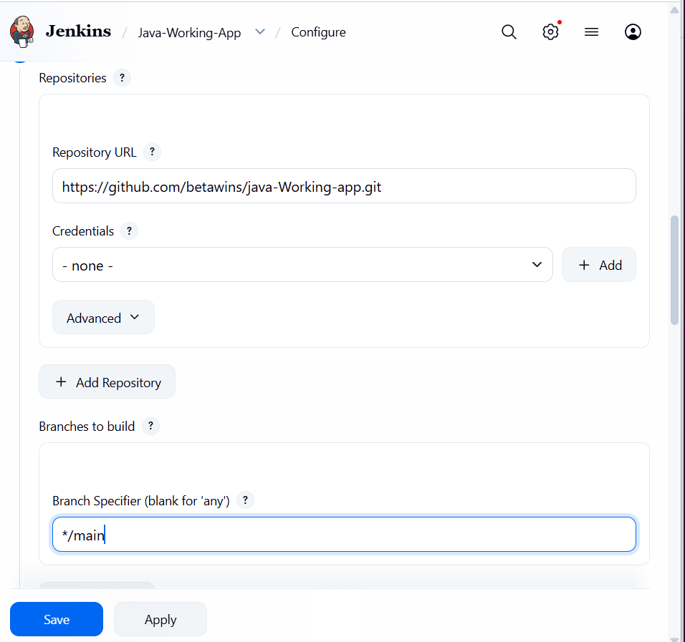

Step 5: Credentials
If the repository is public, you generally don't need GitHub credentials.
If Jenkins asks for credentials and the repository is private, you'll need to configure appropriate Git credentials.
For this exercise, first try without credentials.

Step 6: Configure Maven
Find:
Build
Add:
Invoke top-level Maven targets
You may see:
Maven Version
Goals
For compilation, use:
clean compile
So conceptually:
Maven
↓
clean
↓
compile

⚠️ Important requirement
Your task specifically says:
Stage 1: Git clone
Stage 2: Maven Compilation
A traditional Freestyle/Maven project doesn't give you Pipeline-style stage {} blocks.
Instead, Jenkins internally performs:
SCM checkout
↓
Maven build
If your training material specifically expects visible Stage 1 / Stage 2, a Pipeline job is normally the better fit.
But because your task specifically says Maven Project, we'll follow the Maven project configuration.

Step 7: Save
Click:
Save

Step 8: Build the job
Click:
Build Now
You should see a build:
Build History

#1
Click:
#1
Then:
Console Output
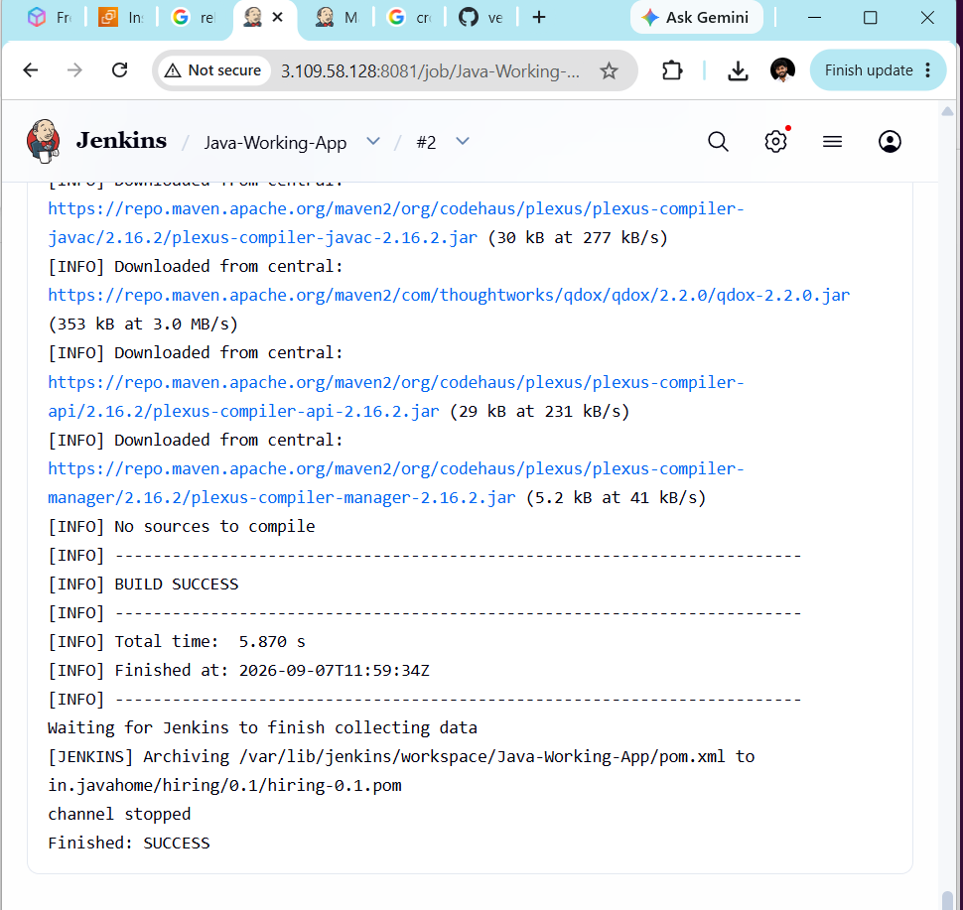

Step 9: Check Git clone
In the console output, look for something similar to:
Cloning the remote Git repository
Then:
Fetching upstream changes
Then:
Checking out Revision ...
This confirms Jenkins successfully cloned the repository.

Step 10: Check Maven compilation
Later in the console output you should see Maven executing.
Something similar to:
[INFO] Scanning for projects...
Then:
[INFO] --- maven-compiler-plugin ...
And finally:
[INFO] BUILD SUCCESS
🎯 That's what we want.

Step 11: Understand clean compile
We used:
mvn clean compile
There are two operations.
clean
Removes the previous build output:
target/
Basically:
Old build
↓
DELETE
compile
Compiles the Java source code.
Java source
↓
Maven compiler
↓
.class files
So:
mvn clean compile
means:
Remove the previous build output and compile the application again.

🧠 Maven lifecycle — important
You should know this for interviews:
validate
↓
compile
↓
test
↓
package
↓
verify
↓
install
↓
deploy
For today's task we're only doing:
clean → compile
Later, we can do:
clean → test → package
which will generate something like:
target/application.jar
or:
target/application.war
depending on the project.

Task 4: Parameterized Jenkins Job
Goal:
Parameter
↓
Jenkins Job
↓
Stage 1 → Git Clone
↓
Stage 2 → Maven Compilation
Same repository:
https://github.com/betawins/java-Working-app.git
🟢 Step 1 — Create a new Jenkins job
Jenkins Dashboard → New Item
Job name:
Java-Working-App-Parameterized
Select:
Pipeline
Click OK.
Here I'm using Pipeline because your requirement explicitly says Stage 1 and Stage 2. Pipeline lets us display those stages clearly.

🟢 Step 2 — Enable parameterization
Inside the job configuration, find:
General
Select:
☑ This project is parameterized
Click:
Add Parameter → Choice Parameter
Configure:
Name:
ENVIRONMENT
Choices:
dev
qa
prod
Description:
Select the environment for the build
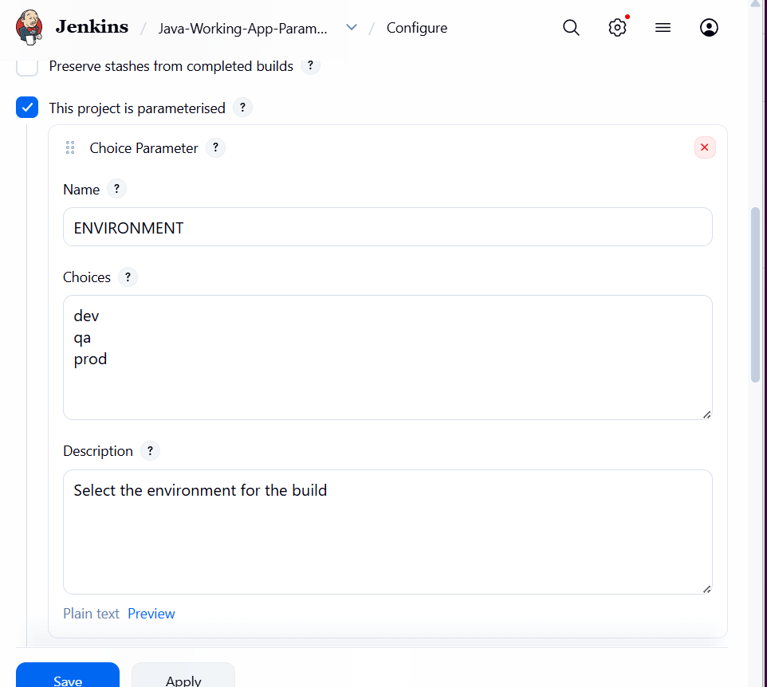
So Jenkins will show:
ENVIRONMENT
○ dev
○ qa
○ prod
Why parameter?
Instead of creating three separate jobs:
Java-App-Dev
Java-App-QA
Java-App-Prod
we can create one job:
Java-Working-App-Parameterized
and choose the environment when starting the build.

🟢 Step 3 — Add Pipeline
Go to:
Pipeline → Pipeline script
Use:
pipeline {
agent any

stages {

stage('Git Clone') {
steps {
git branch: 'main',
url: 'https://github.com/betawins/java-Working-app.git'
}
}

stage('Maven Compilation') {
steps {
sh 'echo "Selected Environment: ${ENVIRONMENT}"'
sh 'mvn clean compile'
}
}
}
}
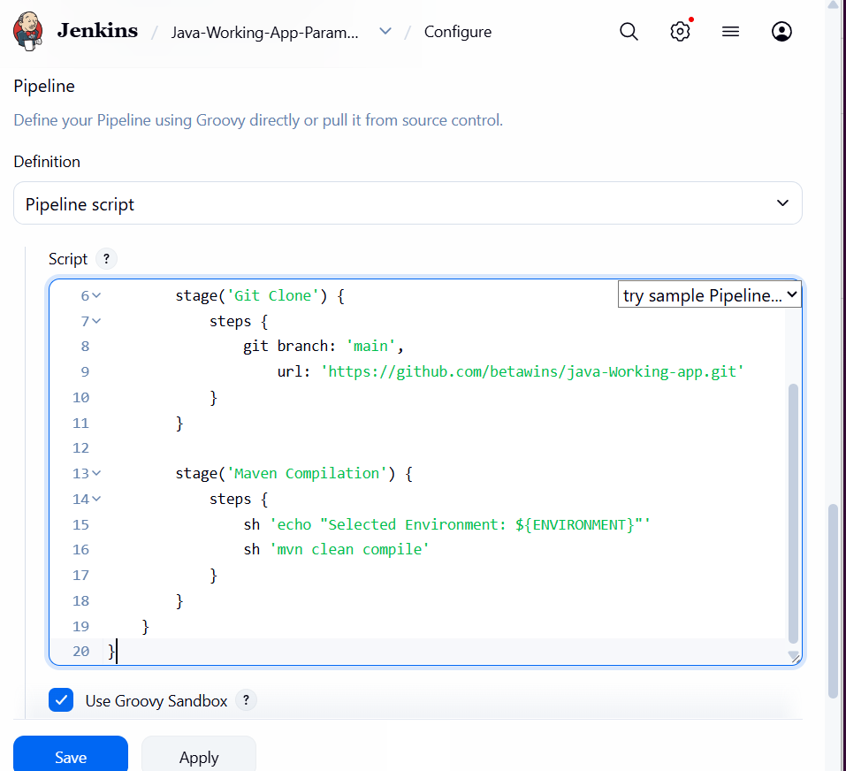

🟢 Step 4 — Save
Click:
Save
Now you'll notice something different.
Instead of simply:
Build Now
Jenkins will provide:
Build with Parameters
That's because this is a parameterized job.

🟢 Step 5 — Build with Parameters
Click:
Build with Parameters
You'll see:
ENVIRONMENT: [dev ▼]
Select:
dev
Then:
Build
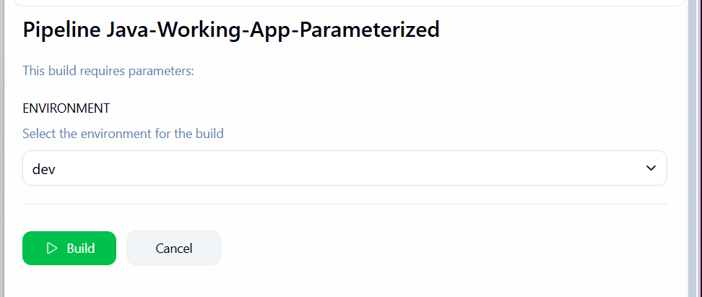

🟢 Step 6 — Check Stage View
After the build starts, Jenkins should show:
Git Clone
✅
↓
Maven Compilation
✅
And in the console you'll see:
Selected Environment: dev
followed by Maven compilation.
At the end:
BUILD SUCCESS
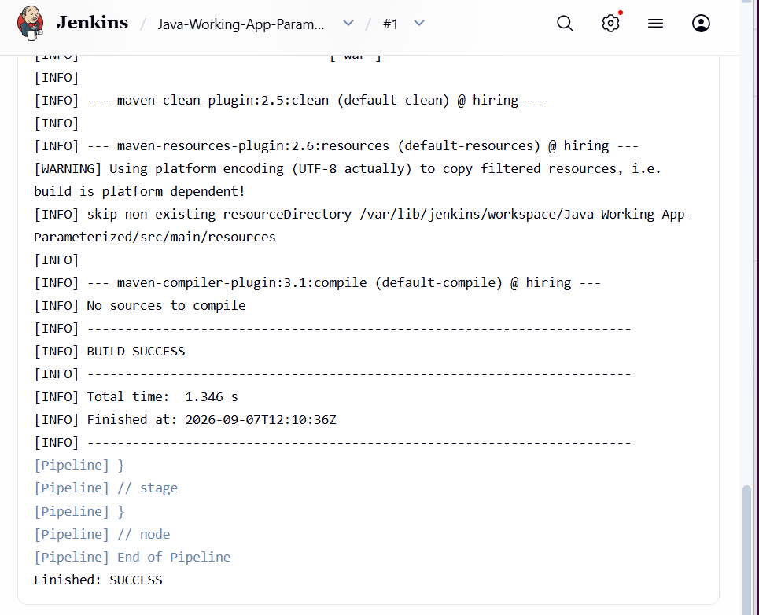

🟢 Step 7 — Try QA
Run again:
Build with Parameters
Select:
qa
Build.
Console:
Selected Environment: qa
The same code is compiled, but the job receives a different parameter.
Try:
prod
You should get:
Selected Environment: prod
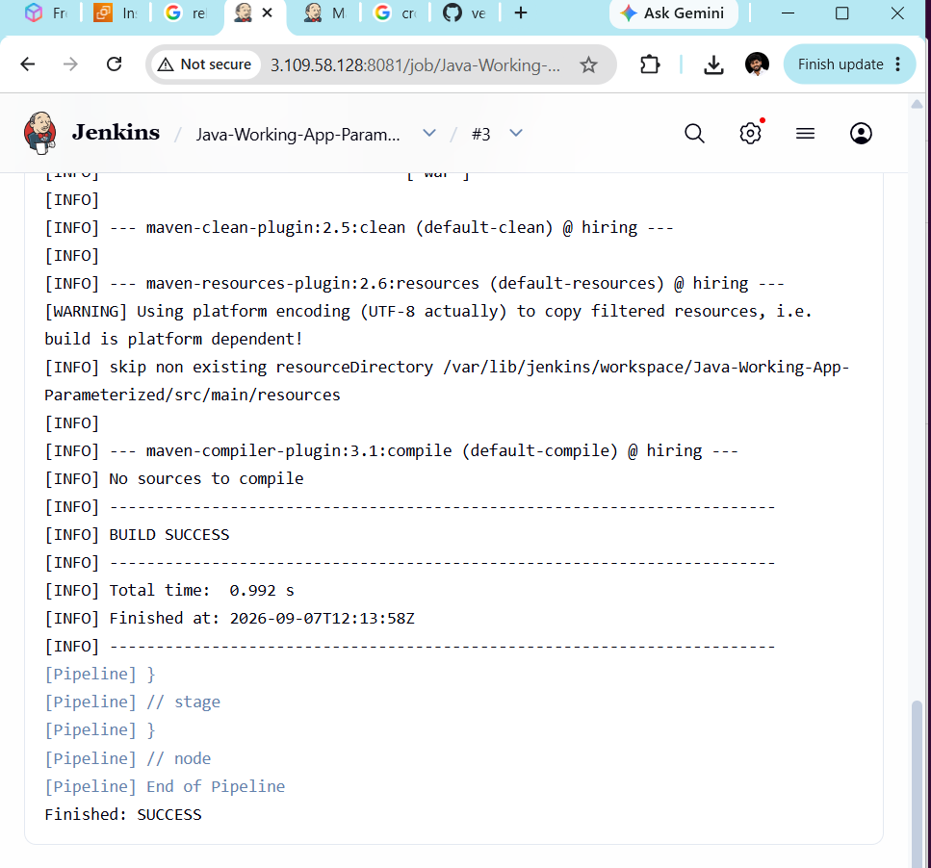

TASK 5 — Jenkins Global Variables
1. First understand what a Jenkins variable is
Jenkins automatically provides information about the current build.
For example:
JOB_NAME → Which job is running?
BUILD_NUMBER → Which build is running?
WORKSPACE → Where is the code checked out?
BUILD_URL → Where can I see this build?
NODE_NAME → Which Jenkins node is running it?
Think of it like:
Jenkins Build
│
┌───────────┼───────────┐
↓ ↓ ↓
JOB_NAME BUILD_NUMBER WORKSPACE
You don't normally create these yourself.
Jenkins provides them.

🟢 Step 1 — Create a test Pipeline
Go to:
Jenkins Dashboard → New Item
Name:
Jenkins-Global-Variables
Select:
Pipeline
Click OK.

🟢 Step 2 — Add Pipeline script
Go to:
Pipeline → Pipeline script
Paste:
pipeline {
agent any

stages {

stage('Global Variables') {
steps {

echo "JOB_NAME = ${env.JOB_NAME}"
echo "BUILD_NUMBER = ${env.BUILD_NUMBER}"
echo "BUILD_ID = ${env.BUILD_ID}"
echo "BUILD_URL = ${env.BUILD_URL}"
echo "WORKSPACE = ${env.WORKSPACE}"
echo "NODE_NAME = ${env.NODE_NAME}"
echo "EXECUTOR_NUMBER = ${env.EXECUTOR_NUMBER}"
echo "JENKINS_HOME = ${env.JENKINS_HOME}"
}
}
}
}
Save.
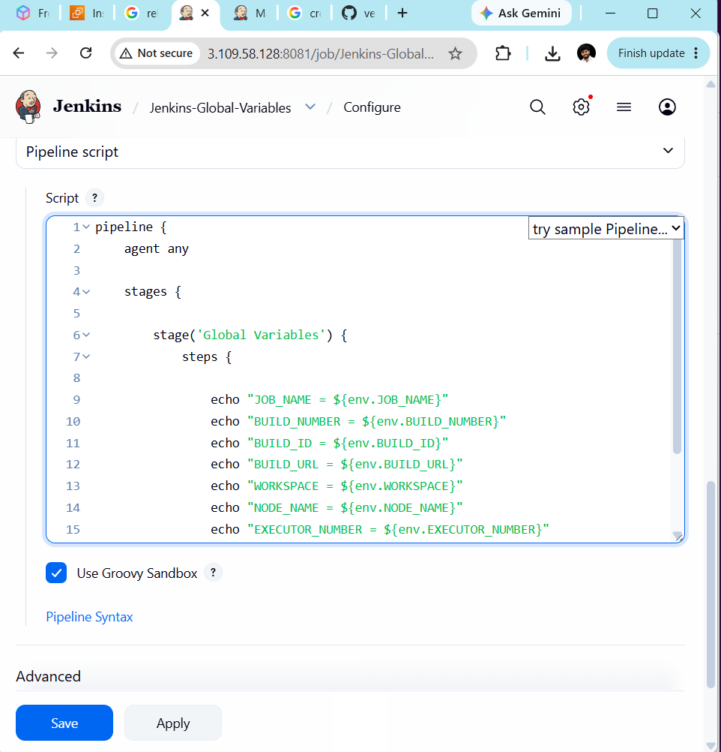

🟢 Step 3 — Build
Click:
Build Now
Then open:
Build #1 → Console Output
You'll see something similar to:
JOB_NAME = Jenkins-Global-Variables
BUILD_NUMBER = 1
BUILD_ID = 1
BUILD_URL = http://...
WORKSPACE = /var/lib/jenkins/workspace/Jenkins-Global-Variables
NODE_NAME = built-in
EXECUTOR_NUMBER = 0
JENKINS_HOME = /var/lib/jenkins
Your actual values will be different.
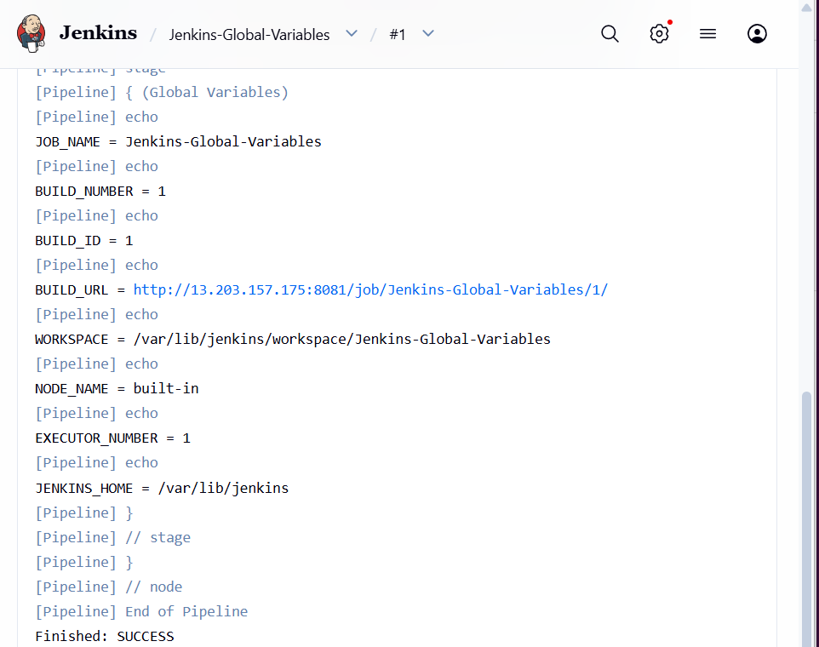

🟢 Step 4 — Understand each variable
1. JOB_NAME
JOB_NAME = Jenkins-Global-Variables
It tells us:
Name of the Jenkins job currently running.
Example:
echo "${env.JOB_NAME}"
Useful for:
- Notifications
- Logs
- Scripts
- Deployment messages

2. BUILD_NUMBER ⭐
Example:
BUILD_NUMBER = 25
It tells us:
Current build number of the Jenkins job.
If you run the job again:
Build #25
Build #26
Build #27
So:
BUILD_NUMBER
↓
Current build sequence number
Example:
echo "Current build: ${env.BUILD_NUMBER}"

3. BUILD_ID
Historically identifies the current build.
Example:
BUILD_ID = 25
Depending on Jenkins/version/plugins, its value can be closely related to the build number.
For modern Pipeline work, you'll more commonly use:
BUILD_NUMBER

4. BUILD_URL ⭐
Example:
BUILD_URL = http://jenkins:8080/job/my-job/25/
It gives the URL of the current build.
Very useful for notifications.
For example:
Build completed successfully.

Build: #25
URL: http://jenkins:8080/job/my-job/25/

5. WORKSPACE ⭐⭐⭐
This is extremely important.
Example:
WORKSPACE=/var/lib/jenkins/workspace/Jenkins-Global-Variables
It is the directory where Jenkins performs the build.
For example:
WORKSPACE
↓
/var/lib/jenkins/workspace/my-job
↓
Git clone
↓
pom.xml
Dockerfile
terraform files
etc.
If you execute:
sh 'pwd'
you'll normally see the current workspace directory.

6. NODE_NAME
Example:
NODE_NAME = built-in
or:
NODE_NAME = Jenkins-Agent01
It tells us:
Which Jenkins node/agent is executing the build.
For example:
Jenkins Controller
|
├── Agent01
└── Agent02
If the job runs on Agent01:
NODE_NAME=Agent01

7. EXECUTOR_NUMBER
Example:
EXECUTOR_NUMBER = 0
It identifies the executor slot running the build on that node.
Think:
Agent
├── Executor 0
├── Executor 1
└── Executor 2
If your build runs in executor 1:
EXECUTOR_NUMBER=1

8. JENKINS_HOME
Example:
JENKINS_HOME=/var/lib/jenkins
This is the Jenkins home directory.
It contains Jenkins data such as:
jobs/
plugins/
users/
workspace/
credentials-related configuration/data
build records
⚠️ Don't casually delete or modify files under JENKINS_HOME.

🟢 Step 5 — Git variables
Now let's add Git-related variables.
Modify your Pipeline:
pipeline {
agent any

stages {

stage('Git Variables') {
steps {
echo "GIT_COMMIT = ${env.GIT_COMMIT}"
echo "GIT_BRANCH = ${env.GIT_BRANCH}"
}
}

stage('Global Variables') {
steps {
echo "JOB_NAME = ${env.JOB_NAME}"
echo "BUILD_NUMBER = ${env.BUILD_NUMBER}"
echo "BUILD_URL = ${env.BUILD_URL}"
echo "WORKSPACE = ${env.WORKSPACE}"
echo "NODE_NAME = ${env.NODE_NAME}"
}
}
}
}
Important ⚠️
GIT_COMMIT and GIT_BRANCH are normally populated when Jenkins performs a Git checkout.
If you don't checkout a Git repository first, they may be empty/not available.
So let's make a proper example.
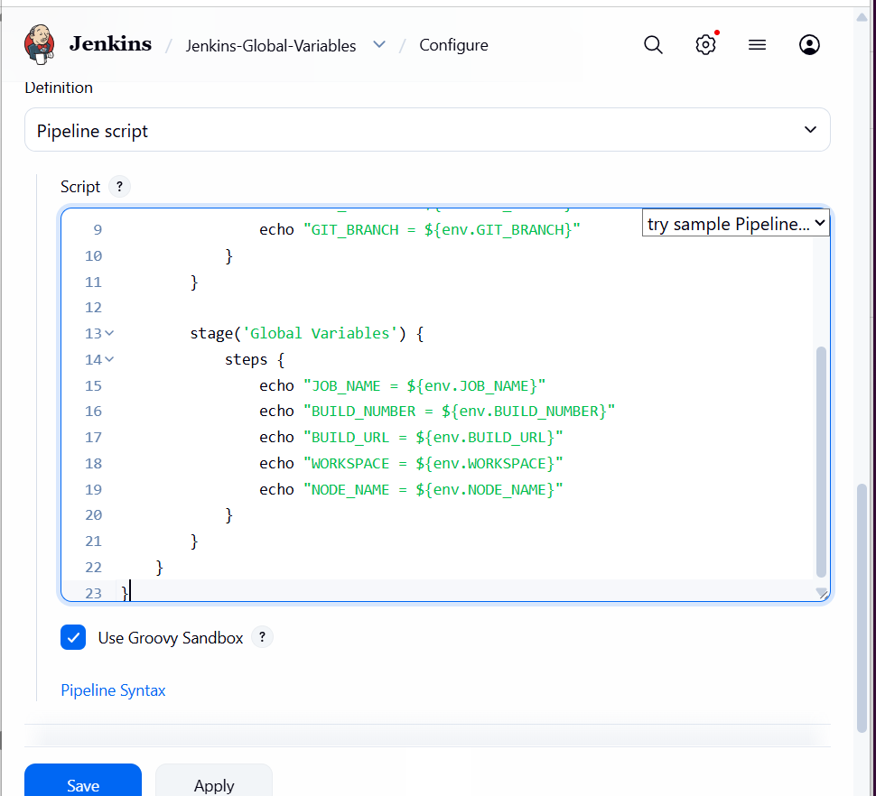
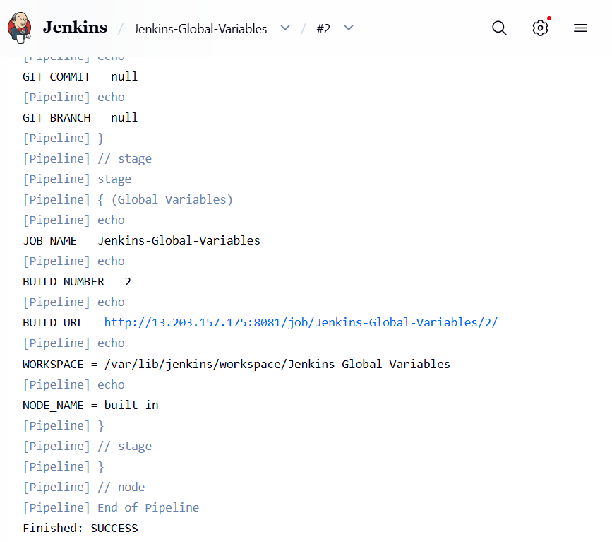

🟢 Step 6 — Git + Global Variables together
Use:
pipeline {
agent any

stages {

stage('Git Clone') {
steps {
git branch: 'main',
url: 'https://github.com/betawins/java-Working-app.git'
}
}

stage('Global Variables') {
steps {

echo "JOB_NAME = ${env.JOB_NAME}"
echo "BUILD_NUMBER = ${env.BUILD_NUMBER}"
echo "BUILD_URL = ${env.BUILD_URL}"
echo "WORKSPACE = ${env.WORKSPACE}"
echo "NODE_NAME = ${env.NODE_NAME}"
echo "EXECUTOR_NUMBER = ${env.EXECUTOR_NUMBER}"

echo "GIT_COMMIT = ${env.GIT_COMMIT}"
echo "GIT_BRANCH = ${env.GIT_BRANCH}"
}
}
}
}
Build it.
Now Git-related information should be available after checkout.
